A MINI PROJECT REPORT

ON
Topic Name
“THIN ICE : A Web based Memory Game”

SUBMITTED BY

Name : Maher Hitesh Patel PRN : 125B1B248
Name : Variya Rajeev Chugh PRN : 125B1B262
Name : Samrudhi Sujeet Vidhate PRN : 125B1B261
Name : Srushti Santosh Nandre PRN : 125B1B249

Under the
guidance of
Prof. Tanya Shruti

First Year Sem-1


DEPARTMENT OF COMPUTER ENGINEERING
PIMPRI CHINCHWAD COLLEGE OF ENGINEERING

2025-2026


DEPARTMENT OF COMPUTER ENGINEERING

PIMPRI CHINCHWAD COLLEGE OF ENGINEERING

Academic Year 2025-26

CERTIFICATE

This is to certify that, the Mini project entitled “THIN ICE : A Web based Memory Game” is successfully carried out as a mini project and successfully submitted by following students of “PCET's Pimpri Chinchwad College of Engineering, Nigdi, Pune-44”. Under the guidance of Prof. Tanya Shruti In the partial fulfilment of the requirements for the First Year B. Tech. Computer Engineering.

Group Members

Project Guide Name: Prof. Tanya Shruti
Signature: Name : Maher Hitesh Patel PRN : 125B1B248
Name : Variya Rajeev Chugh PRN : 125B1B262
Name : Samrudhi Sujeet Vidhate PRN : 125B1B261
Name : Srushti Santosh Nandre PRN : 125B1B249

Table of Contents
Rubric Table for Assessment of Mini Project
Performance Indicators | Performance levels (PL)  Divide Maximum Marks by the number of performance levels to obtain the increment or decrement of marking |  |  |  | Maximum  Marks
1.Understanding of Problem Statement | Problem is extremely clear, specific, and well-defined.  Objectives and goals are highly specific and measurable.  (5) | Problem is clear, specific, and well-defined.  Objectives and goals are specific and measurable.  (4) | Problem is somewhat clear, specific, and well-defined.  Objectives and goals are somewhat specific and measurable.  (2-3) | Problem is poorly defined. Some Objectives and goals are missing or irrelevant.  (0-1) | 5
2.Tools/ libraries used for Implementation | Selected and used highly relevant, appropriate tools to implement the objectives.  (5) | Selected and used relevant, appropriate tools to implement the objectives.  (4) | Selected and used relevant, appropriate tools to implement some objectives.  (2-3) | Selected and used irrelevant, inappropriate tools to implement very few objectives.  (0-1) | 5
3.Result and Conclusion | Analysis of results is highly relevant and informative. Conclusions are very clear, concise, and  well-summarized.  (5) | Analysis of results is relevant and informative.  Conclusions are clear, concise, and well-summarized.  (4) | Analysis of results is somewhat relevant and informative.  Conclusions are somewhat clear, concise, and  well-summarized.  (2-3) | Analysis of results is hardly relevant and informative. Conclusions are hardly clear, concise, and  well-summarized.  (0-1) | 5
4. Documentation  , Quality of the report, Knowledge and communication | Presentation, Knowledge and communication are highly structured and  well-organized. Documentation is comprehensive and covers all aspects of the project.  (5) | Presentation, Knowledge, and communication are structured and organized.  Documentation is mostly complete and covers all aspects of the project.  (4) | Presentation, Knowledge, and communication are somewhat structured and organized.  Documentation is partially completed and covers few aspects of the project.  (2-3) | Presentation, knowledge, and communication are poor and unorganized.  Documentation is not completed and does not covering the aspects of the project.  (0-1) | 5
 |  |  |  | Total | 20

Evaluation Sheet

Department of Computer Engineering
Class : FY | Semester: I |  |  |  |  | Year: 2025-26
Name of the Course | CPPS/DECO |  | Name of the Faculty:
Mini Project |  | 1 | 2 | 3 | 4 | Total Marks
PRN | Name of the Student | 5M | 5M | 5M | 5M | 20M
125B1B248 | Maher Hitesh Patel
125B1B262 | Variya Rajeev Chugh
125B1B262 | Samrudhi Sujeet Vidhate
125B1B249 | Srushti Santosh Nandre

Project Guide Signature

1. Introduction
1.1 What is the project about?
The project, titled Thin Ice, is an interactive, browser-based memory puzzle game. The core gameplay involves a grid of ice tiles where a specific safe path is briefly revealed to the player. The player must memorize this sequence and navigate their character from the starting point to the goal using keyboard arrow keys. If the player deviates from the memorized path, the "ice cracks," and the level is lost.
1.2 Why this project was chosen ?
This project was selected to demonstrate the integration of core web technologies—HTML, CSS, and JavaScript—to create a dynamic user experience. It focuses on implementing logical path generation, state management (win/loss conditions), and interactive UI elements such as timers and character selection.

2. Problem Statement
- Clear statement of the problem: To design a memory-based challenge where players navigate an $8 \times 8$ grid while adhering to a hidden, randomly generated path.
- Input and output expected:
  - Input: User selection of player icons and keyboard directional inputs (ArrowUp, ArrowDown, ArrowLeft, ArrowRight).
  - Output: Real-time movement of the character on the grid, visual feedback for correct/incorrect moves (cracked ice effect), and level progression.
- Real-life relevance: This project serves as an exercise in cognitive memory training and demonstrates how front-end web development can be used to build lightweight, accessible educational tools or entertainment applications.

3. Objectives of the Project
- To implement a random path generation algorithm that increases in length as the player levels up.
- To create a responsive and themed User Interface using CSS gradients and animations.
- To manage game states including "Home," "Game," and "Result" overlays using JavaScript DOM manipulation.
- To integrate audio feedback and high-score tracking using local browser storage.

4. Software / Hardware Requirements
- Software:
  - Operating System: Windows/macOS/Linux/Android/iOS.
  - Development Tools: Text Editor (VS Code, Notepad++, or Acode).
  - Execution Environment: Modern Web Browser (Chrome, Firefox, Safari).
- Hardware:
  - Standard Computer or Smartphone.
  - Keyboard (for desktop play) or Touchscreen (for mobile play).

5. Algorithm
- Start: Load the Home screen and wait for the "Start" trigger.
- Initialize Level: Clear the grid, generate a random path of length ($level + 4$), and set the player at the start.
- Reveal: Briefly show the safe path to the player using the revealPath function.
- Listen: Accept keyboard inputs and calculate the next tile position.
- Validate: * If next is part of the path, move the player and play a success tone.
  - If next is not on the path, trigger the "Ice Cracked" loss state.
- Win Condition: If the player reaches the final tile in the path, increment the level and show the victory screen.
- End

6. Flowchart

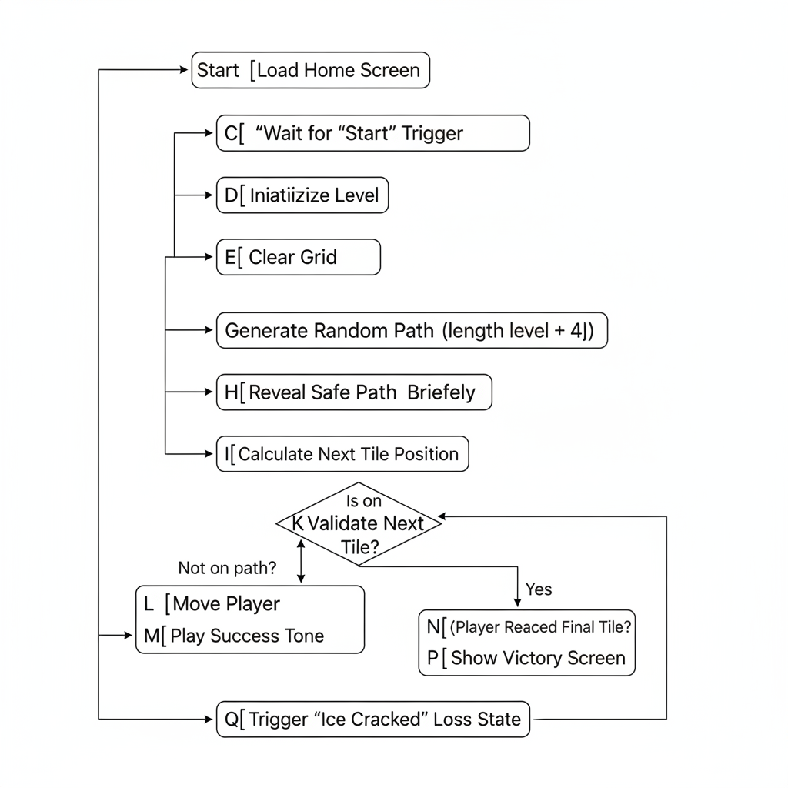

7. Program Code
The program is implemented across three primary files: index.html for structure, style.css for the winter-themed visuals, and script.js for the game logic and sound engine.
<!DOCTYPE html>
<html lang="en">
<head>
<meta charset="UTF-8" />
<meta name="viewport" content="width=device-width, initial-scale=1.0">
<title>Thin Ice</title>
<style>
:root {
--ice-blue: #a5f3fc;
--deep-blue: #0c4a6e;
--crack-color: #e0f2fe;
--highlight: #fde047;
}

body {
margin: 0;
font-family: 'Segoe UI', sans-serif;
background: linear-gradient(to bottom, #1e3a8a, #0f172a);
color: white;
text-align: center;
overflow: hidden;
height: 100vh;
}

/* Snowflake Decoration */
.snowflake {
position: absolute; top: -10px; color: white; user-select: none; z-index: -1;
animation: fall linear infinite;
}
@keyframes fall { to { transform: translateY(105vh); } }

.screen { display: none; padding: 20px; }
.active { display: block; }

/* UI Elements */
.stats { display: flex; justify-content: space-around; font-size: 1.2rem; margin: 10px; }
#timer-bar { width: 200px; height: 10px; background: #334155; margin: 10px auto; border-radius: 5px; overflow: hidden; }
#timer-fill { width: 100%; height: 100%; background: var(--ice-blue); transition: width 0.1s linear; }

/* Ice Grid */
#grid {
display: grid;
grid-template-columns: repeat(8, 50px);
gap: 5px;
justify-content: center;
margin: 20px auto;
perspective: 1000px;
}

.tile {
width: 50px;
height: 50px;
background: rgba(165, 243, 252, 0.2);
border: 1px solid rgba(255, 255, 255, 0.3);
border-radius: 4px;
position: relative;
}

/* States */
.path-hint { background: var(--ice-blue) !important; box-shadow: 0 0 15px var(--ice-blue); }
.player { font-size: 24px; display: flex; align-items: center; justify-content: center; z-index: 2; }
.goal { background: #10b981; box-shadow: 0 0 10px #10b981; }
.wrong { background: #ef4444 !important; }

.cracked {
background: var(--crack-color) !important;
background-image: repeating-linear-gradient(45deg, transparent, transparent 2px, rgba(0,0,0,0.1) 3px) !important;
}

/* Highlighting selected icon */
.icon-select button {
font-size: 24px; margin: 5px; padding: 10px; cursor: pointer;
background: rgba(165, 243, 252, 0.2); border: 2px solid transparent; border-radius: 10px;
}
.icon-select button.selected {
border-color: var(--highlight);
box-shadow: 0 0 15px var(--highlight);
background: var(--deep-blue);
}

/* Animations */
.shake { animation: shake 0.4s; }
@keyframes shake {
0%, 100% { transform: translateX(0); }
25% { transform: translateX(-8px); }
75% { transform: translateX(8px); }
}

/* Overlays */
.overlay { position: fixed; inset: 0; background: rgba(0,0,0,0.85); display: flex; align-items: center; justify-content: center; z-index: 100; }
.hidden { display: none !important; }
.popup { background: var(--deep-blue); padding: 30px; border-radius: 20px; border: 3px solid var(--ice-blue); }

button {
padding: 10px 25px; margin: 10px; cursor: pointer;
background: var(--ice-blue); border: none; border-radius: 8px; font-weight: bold;
}
button:disabled { opacity: 0.5; cursor: not-allowed; }
</style>
</head>
<body>

<div id="home" class="screen active">
<h1 style="font-size: 3.5rem; margin-bottom: 0;">THIN ICE</h1>
<div style="margin: 10px 0;"><strong>HIGH SCORE: LEVEL <span id="highScoreDisplay">1</span></strong></div>

<div class="icon-select" id="iconGroup">
<p>Select Character</p>
<button onclick="selectIcon(this, '☃️')" class="selected">☃️</button>
<button onclick="selectIcon(this, '🐧')">🐧</button>
<button onclick="selectIcon(this, '🧊')">🧊</button>
<button onclick="selectIcon(this, '🎅')">🎅</button>
</div>
<button style="font-size: 1.5rem;" onclick="startGame()">Start Journey</button>
<br>
<button id="musicBtn" style="background:none; border:1px solid white; color:white; font-size:0.8rem;" onclick="toggleMusic()">🎵 Music: ON</button>
</div>

<div id="game" class="screen">
<div class="stats">
<span>Level: <span id="currentLevel">1</span></span>
<span>Time: <span id="timeText">0</span>s</span>
</div>
<div id="timer-bar"><div id="timer-fill"></div></div>
<button id="revealBtn" onclick="revealPath()">Reveal Path</button>
<div id="grid"></div>
<button style="background:none; border:none; color:white; cursor:pointer;" onclick="confirmQuit()">Quit to Menu</button>
</div>

<div id="result" class="overlay hidden">
<div class="popup">
<h2 id="resultText"></h2>
<button onclick="restartLevel()">🔁 Try Again</button>
<button id="nextBtn" onclick="nextLevel()">➡ Next Level</button>
<button onclick="goHome()">🏠 Main Menu</button>
</div>
</div>

<div id="quitOverlay" class="overlay hidden">
<div class="popup">
<h2>Quit Game?</h2>
<p>Progress for this level will be lost.</p>
<button onclick="goHome()">Yes, Quit</button>
<button style="background:#475569; color:white;" onclick="closeQuit()">No, Stay</button>
</div>
</div>

<script>
let level = 1;
let highScore = localStorage.getItem('thinIceHS') || 1;
const size = 8;
let path = [];
let playerPos = 0;
let goalPos;
let playerIcon = "☃️";
let isPlaying = false;
let timerInterval;
let timeLeft = 0;
let musicEnabled = true;
let musicInterval;

const audioCtx = new (window.AudioContext || window.webkitAudioContext)();
document.getElementById('highScoreDisplay').innerText = highScore;

// Classic Sound Engine
function playTone(freq, type, duration, vol = 0.1) {
const osc = audioCtx.createOscillator();
const gain = audioCtx.createGain();
osc.type = type;
osc.frequency.setValueAtTime(freq, audioCtx.currentTime);
gain.gain.setValueAtTime(vol, audioCtx.currentTime);
gain.gain.exponentialRampToValueAtTime(0.01, audioCtx.currentTime + duration);
osc.connect(gain); gain.connect(audioCtx.destination);
osc.start(); osc.stop(audioCtx.currentTime + duration);
}

// Background Music logic
function playMusic() {
if (!musicEnabled) return;
let step = 0;
const notes = [130, 146, 164, 196];
musicInterval = setInterval(() => {
if (musicEnabled) {
playTone(notes[step % 4], 'triangle', 0.5, 0.03);
if (step % 4 === 0) playTone(523, 'sine', 0.8, 0.01);
step++;
}
}, 600);
}

function toggleMusic() {
musicEnabled = !musicEnabled;
document.getElementById('musicBtn').innerText = musicEnabled ? "🎵 Music: ON" : "🔇 Music: OFF";
if (!musicEnabled) clearInterval(musicInterval);
else playMusic();
}

// Snowflakes
for(let i=0; i<30; i++) {
let snow = document.createElement('div');
snow.className = 'snowflake'; snow.innerText = '❄';
snow.style.left = Math.random() * 100 + 'vw';
snow.style.animationDuration = (Math.random() * 3 + 2) + 's';
snow.style.opacity = Math.random();
document.body.appendChild(snow);
}

function selectIcon(btn, icon) {
playerIcon = icon;
document.querySelectorAll('#iconGroup button').forEach(b => b.classList.remove('selected'));
btn.classList.add('selected');
playTone(440, 'sine', 0.1);
}

function startGame() {
if (audioCtx.state === 'suspended') audioCtx.resume();
level = 1;
show("game");
if (!musicInterval && musicEnabled) playMusic();
initLevel();
}

function initLevel() {
clearInterval(timerInterval);
document.getElementById("grid").classList.remove("shake");
document.getElementById("currentLevel").innerText = level;
document.getElementById("revealBtn").disabled = false;
path = generatePath();
playerPos = path[0];
goalPos = path[path.length - 1];
timeLeft = Math.max(5, path.length * 1.5);
updateTimerUI();

const grid = document.getElementById("grid");
grid.innerHTML = "";
for (let i = 0; i < 64; i++) {
const tile = document.createElement("div");
tile.className = "tile";
grid.appendChild(tile);
}
draw();
isPlaying = false;
}

function generatePath() {
let p = [0], curr = 0, len = 4 + level;
while (p.length < len) {
let moves = [];
if (curr + 8 < 64) moves.push(curr + 8);
if ((curr + 1) % 8 !== 0) moves.push(curr + 1);
if (curr % 8 !== 0) moves.push(curr - 1);
let valid = moves.filter(m => !p.includes(m));
if (valid.length === 0) break;
curr = valid[Math.floor(Math.random() * valid.length)];
p.push(curr);
}
return p;
}

function revealPath() {
document.getElementById("revealBtn").disabled = true;
path.forEach(idx => document.querySelectorAll(".tile")[idx].classList.add("path-hint"));
playTone(300, 'triangle', 0.5);
setTimeout(() => {
path.forEach(idx => document.querySelectorAll(".tile")[idx].classList.remove("path-hint"));
startTimer();
isPlaying = true;
}, 1500);
}

function startTimer() {
timerInterval = setInterval(() => {
timeLeft -= 0.1;
updateTimerUI();
if (timeLeft <= 0) lose("timeout");
}, 100);
}

function updateTimerUI() {
document.getElementById("timeText").innerText = Math.ceil(timeLeft);
let total = path.length * 1.5;
document.getElementById("timer-fill").style.width = (timeLeft / total * 100) + "%";
}

function draw() {
const tiles = document.querySelectorAll(".tile");
tiles.forEach((t, i) => {
t.classList.remove("player"); t.innerText = "";
if (i === playerPos) { t.classList.add("player"); t.innerText = playerIcon; }
if (i === goalPos) t.classList.add("goal");
});
}

document.addEventListener("keydown", e => {
if (!isPlaying) return;
let step = 0;
if (e.key === "ArrowUp") step = -8;
if (e.key === "ArrowDown") step = 8;
if (e.key === "ArrowLeft" && playerPos % 8 !== 0) step = -1;
if (e.key === "ArrowRight" && (playerPos + 1) % 8 !== 0) step = 1;
if (step !== 0) movePlayer(step);
});

function movePlayer(step) {
let next = playerPos + step;
let pathIdx = path.indexOf(playerPos);
if (path[pathIdx + 1] === next) {
playerPos = next;
playTone(500 + (pathIdx * 50), 'sine', 0.15);
draw();
if (playerPos === goalPos) win();
} else if (path[pathIdx - 1] !== next) {
lose(next);
}
}

function win() {
isPlaying = false; clearInterval(timerInterval);
playTone(800, 'square', 0.2);
setTimeout(() => playTone(1000, 'square', 0.4), 200);
if (level >= highScore) {
highScore = level;
localStorage.setItem('thinIceHS', level);
document.getElementById('highScoreDisplay').innerText = highScore;
}
document.getElementById("resultText").innerText = "Victory!";
document.getElementById("nextBtn").disabled = false;
document.getElementById("result").classList.remove("hidden");
}

function lose(failPos) {
isPlaying = false; clearInterval(timerInterval);
playTone(150, 'sawtooth', 0.5);
document.getElementById("grid").classList.add("shake");
let reachedIdx = path.indexOf(playerPos);
for(let i=0; i<=reachedIdx; i++) {
document.querySelectorAll(".tile")[path[i]].classList.add("cracked");
}
if (failPos !== "timeout") document.querySelectorAll(".tile")[failPos].classList.add("wrong");
setTimeout(() => {
document.getElementById("resultText").innerText = failPos === "timeout" ? "Time's Up!" : "Ice Cracked!";
document.getElementById("nextBtn").disabled = true;
document.getElementById("result").classList.remove("hidden");
}, 800);
}

function confirmQuit() { isPlaying = false; document.getElementById("quitOverlay").classList.remove("hidden"); }
function closeQuit() { isPlaying = true; document.getElementById("quitOverlay").classList.add("hidden"); }
function restartLevel() { document.getElementById("result").classList.add("hidden"); initLevel(); }
function nextLevel() { level++; document.getElementById("result").classList.add("hidden"); initLevel(); }
function goHome() { location.reload(); }
function show(id) { document.querySelectorAll(".screen").forEach(s => s.classList.remove("active")); document.getElementById(id).classList.add("active"); }
</script>
</body>
</html>

8. Sample Input and Output
- Sample Input: User presses ArrowRight when the next safe tile is to the right of the current position.
- Sample Output: The character icon (e.g., 🐧) moves to the right tile, a 500Hz sine wave tone plays, and the tile does not turn red.
- Screenshots: (Insert screenshots of the Main Menu with character selection and the Game Grid with the revealed path).

9. Result and Observations
- What did the program achieve? The program successfully creates a playable, bug-free memory game that tracks progress across levels.
- Was the output correct? Yes, path validation correctly identifies safe versus dangerous tiles, and the timer accurately reflects the difficulty of the path length.
- Did it meet objectives? All objectives, including high-score persistence and visual feedback, were met.

10. Learning Outcome
- Syntax of Web Languages: Gained proficiency in modern JavaScript (ES6) and CSS Flexbox/Grid layouts.
- Logic building: Developed a robust path-validation algorithm and managed asynchronous events like setTimeout for the path reveal.
- Debugging skills: Improved ability to use Browser Developer Tools to trace logic errors in player movement.

11. Conclusion
Thin Ice provides an engaging way to test memory while demonstrating the power of vanilla web technologies. The solution is effective due to its low hardware requirements and intuitive controls. Future improvements could include mobile-friendly touch controls and additional environmental hazards like "sliding ice" tiles.

12. References
- MDN Web Docs (JavaScript AudioContext and Event Listeners)
- Programming in ANSI C by E. Balagurusamy (for logic foundation)

